Insert a map of your route here
Routes should take anywhere from 30 minutes to two hours to complete and will ideally be a looped route. An example route is pictured below:
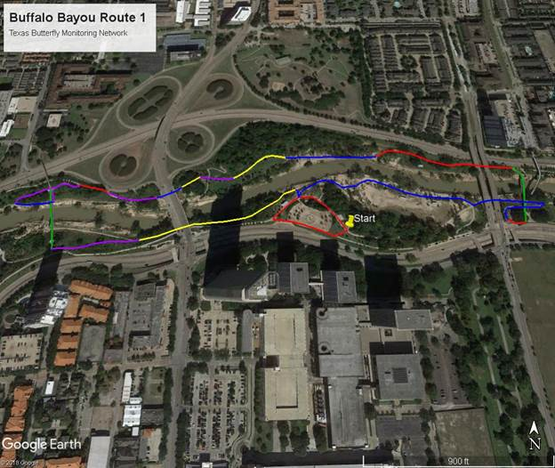
An ideal route is in a natural or semi-natural area and goes through several different habitats. Each of the colors on the route above designates a habitat. You get to pick your own habitat labels, and we ask that you have five different habitats. My habitats for the attached map are listed below:
Habitat A (red): Roadside
Habitat B (blue): Sandy floodplain
Habitat C (green): Man-made bridges
Habitat D (yellow): Open Woodland
Habitat E (purple): Marsh

If you do not want to choose your own route, you can request a pre-mapped route in a particular area, and we will be able to assign you one.

